Step by step guide Driver

1. The driver logs on at the start of his or her shift (only needs to logon one time).

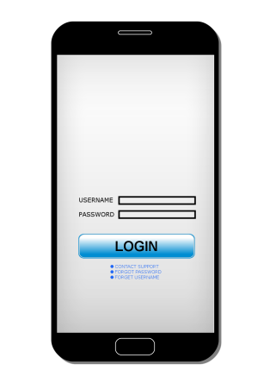

1. The assignment list is displayed with GPS coordinates for navigation.

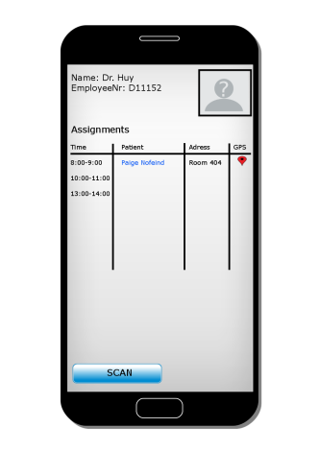

1. When the driver picks up or delivers a patient he or she logs the event and it is displayed in the patient history. The family can see the information in the timetable.
2. The driver can send messages to the state, family or senior center if a patient has any special needs.